**NAME :**

**SURNAME:**

**DATE:**

**TIL I EXAM (1)**



**READING COMPREHENSION & LOGIC ( 10 QUESTIONS 20 MINS )**

Contamination is the unintended presence of harmful substances or organisms in food. While it is true that recent scientific advances have resulted in safer foods, better methods of preservation, and improved storage practices, it is still necessary to guard against the practices that can increase the likelihood of food contamination. Because food-borne illness poses a potentially serious threat to public health, preventing contamination of safe food needs to be a prime objective of every food service manager. Furthermore, a food service manager must possess accurate information on the different hazards associated with the contamination of food in the event that a food-borne illness crisis does arise. A full understanding of the biological, chemical, and physical hazards allows the food service manager to implement the control measures necessary to minimize the health risks associated with food and, thus, to decrease the possibility of contamination.

The most serious risk associated with food is the biological hazard. Biological hazards are dangers to food from pathogenic (disease-causing) microorganisms, such as bacteria, viruses, parasites, and fungi, and from toxins that occur in certain plants and fish. When biological hazards result in food-borne illnesses, these illnesses are generally classified as either infections or intoxications. A food-borne infection is a disease that results from eating food containing living harmful microorganisms. One of the most frequently reported diseases of this type is salmonellosis, which results from the consumption of food contaminated with live pathogenic Salmonella.

The other major form of biologically induced food-borne illness is intoxication, which results when toxins, or poisons, from bacterial or mold growth are present in ingested food and cause illness in the host (the human body). These toxins are generally odorless and tasteless and are capable of causing disease even after the microorganisms have been killed. Staphylococcus food intoxication is one of the most common types of foodborne illness reported in the United States.

**1-** Which of the following best expresses the main idea of the passage?

**A-** Despite recent scientific advances, food-borne illness continues to present a serious risk to public health.

**B-** Although chemical and physical hazards can cause a food-borne illness, biological hazards pose the most serious risk of food contamination.

**C-** Knowledge of contamination sources is essential for a food service manager to safely operate a food establishment.

**D-** Biological, chemical, and physical hazards represent the main sources of food contamination.

**E-** The illnesses caused by the contamination of food by biological hazards take the form of either a food-borne infection or a food-borne intoxication.

**2-** The author of the passage would most likely agree that a food service manager’s comprehension of the nature of potential food hazards is

**A-** crucial to the safety of a food service operation.

**B-** necessarily limited due to the complexity of contamination sources.

**C-** the primary factor in an employer’s decision to hire that manager.

○ utilized exclusively for the prevention of food-borne illness.

○ vitally important but nearly impossible to attain.

3- According to the passage, pathogenic microorganisms

**A-** are the most common form of biological hazard.

**B-** can only trigger a food-borne illness when alive.

**C-** are toxins that occur in certain plants and fish.

○ include life forms such as bacteria and parasites.

○ are difficult to detect because they are odorless and tasteless.

Modern methods of predicting earthquakes recognize that quakes, far from being geologic anomalies, are part of the periodic accumulation and discharge of seismic energy. As continents receive the horizontal thrust of seafloor plates, crustal strains develop. Accumulation of strain can take anywhere from 100 years in certain coastal locations to over a millennium in some inland regions before a critical point is reached and a rupture occurs. In both areas, the buildup of strain is accompanied by long- and short-range precursory phenomena that are crucial to earthquake prediction.

Quakes along active faults—like those along the Pacific coasts—are usually frequent; scientists designate such areas as quake-prone. However, when the time interval between quakes is great, as in inland regions, locating active faults is only a beginning. Geological scars of past subsidence, cracks, and offsets are useful in determining potential quake locations, as are seismicity gaps, areas where no small quakes have been recorded. Seismologists may also consult the historical record. Primary sources range from eyewitness accounts of ancient quakes to recent official documentation of quake-related damage.

Once the perimeters of a quake-prone zone are established, a network of base stations can monitor precursory phenomena. Stations must extend over a wide area yet be placed at measured intervals to obtain precise readings. Changes in geochemical readings (electric currents, radon concentrations) and in groundwater levels, as well as the occurrence of microearthquakes, are valuable precursors. Crustal movements—tilting, rising, and expansion or contraction of the ground’s surface—can be read through triangulation and leveling surveys taken over the course of decades. Theoretically, if an area’s critical strain—the magnitude of strain necessary to produce a rupture—is known, subtracting the measured accumulated crustal strain from the critical strain will indicate a time frame for an impending quake.

Violent tilting and foreshocks are among phenomena classified as short-term precursors. Many are still being identified as new quakes occur. Such precursors are valuable since their appearance can permit prediction of a quake to within hours of the primary rupture. Here, too, historical documents are useful. Seismologists recognized the liquefaction of sand as a precursor after a 1964 quake in Japan.

4- According to the passage, a major difference between coastal regions and inland regions is that in coastal regions

**A-** crustal strain does not occur.

**B-** earthquakes are less numerous.

**C-** critical points are reached more quickly.

**D-** precursory phenomena are seldom observed.

**E-** seafloor plate action is less powerful.

5- The primary purpose of the passage is to

**A-** clarify the way in which earthquakes develop in inland locations.

**B-** show that earthquakes are a result of the normal accumulation and discharge of seismic energy.

**C-** discuss the accumulation of crustal strain in coastal regions.

**D-** argue that precursory phenomena should be disregarded in attempts at quake prediction.

**E-** describe methods of earthquake prediction and explain the importance of precursory phenomena.

6- The primary function of the third paragraph is to

**A-** explain the relationship between accumulated and critical strain.

**B-** describe the use of precise intervals in establishing networks of base stations.

**C-** summarize the differences between earthquakes in coastal and inland regions.

**D-** outline some of the methods used by seismologists to predict earthquakes.

**E-** suggest that critical strain is not spread evenly along most major fault lines

|  |  |
| --- | --- |
| 7  8 |  |
| 9 |  |
| 10 |  |
|  |  |
|  |  |

**MATHS ( 16 QUESTIONS 36 MINS )**

|  |  |
| --- | --- |
| 1  2  3 |  |
| 4 |  |
| 5 |  |
| 6 |  |
| 7 |  |
| 8  9 |  |
| 10  11 |  |
| 12  13 |  |
| 14 |  |
| 15 |  |
| 16 |  |
|  |  |
|  |  |

**PHYSICS ( 10 QUESTIONS 22 MINS )**

|  |  |
| --- | --- |
| 1 |  |
| 2 | **A** 39  **B** 43  **C** 20  **D** 35  **E** 15 |
| 3 | **E 1.5 ms** |
| 4 | **E** 15.0 m/s |
| 5 | **E** 40.000 N |
| 6 | **E none of the above** |
| 7 |  |
| 8 | **A** 2 m/s2    **B** 6 m/s2  **C** 12 m/s  **D** 8 m/s2  **E** 4 m/s2 |
| 9 |  |
| 10 | **E** None of the above |

**BASIC TECHNICAL KNOWNLEDGE ( 6 QUESTIONS 12 MINS)**

1. The code segment below is intended to swap the values of the variables first and second using a temporary variable, temp

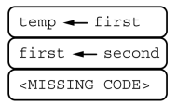

Which of the following can be used to replace so that the code segment works as intended?

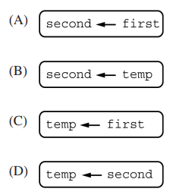

2. A bank customer receives an e-mail from a sender claiming to be a bank employee. The e-mail asks the customer to provide personal information and to call a phone number if he or she has any questions. The customer suspects the e-mail might be a phishing attempt. Which of the following responses is most likely to be a privacy risk for the bank customer?

(A) Calling the bank at its official phone number to ask whether the request for personal information is legitimate

(B) Calling the phone number given in the e-mail and providing the personal information over the phone

(C) Checking that the domain name of the sender’s e-mail address is associated with the bank

(D) Conducting a Web search to see if other people have received similar requests for personal information

3. Which of the following would be the best use of citizen science?

(A) An experiment that requires all participants to be working in the same laboratory

(B) An experiment that requires expensive equipment to conduct

(C) An experiment that requires data measurements to be taken in many different locations

(D) An experiment that requires specialized knowledge and training to conduct

4. A student is writing a program to model different real-world events using simulations. Which of the following simulations will generate a result that would best be stored using a Boolean variable?

(A) A simulation of flipping a fair coin

(B) A simulation of rolling a fair die (with sides numbered 1 through 6)

(C) A simulation of the temperature in a location over time

(D) A simulation of traffic patterns on a road

**5.** The ticket prices at a movie theater are given below.

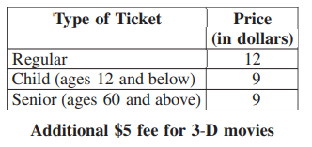

A programmer is creating an algorithm to set the value of ticketPrice based on the information in the table. The programmer uses the integer variable age for the age of the moviegoer. The Boolean variable is3D is true when the movie is 3-D and false otherwise.

Which of the following code segments correctly sets the value of ticketPrice?

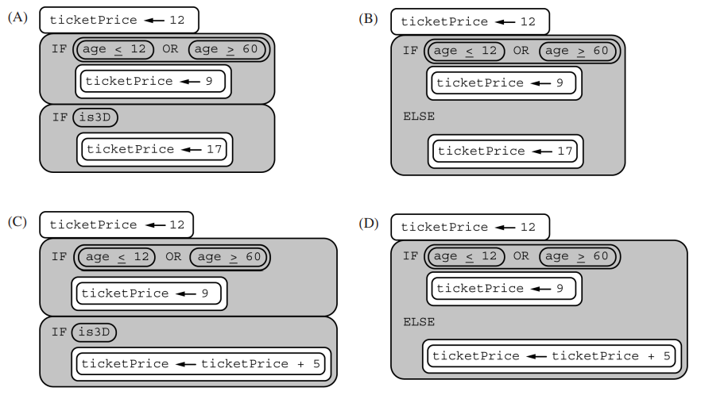

**6.** Consider the following program, which uses the variables start, end, and current.

Start 🡨 1

End 🡨 20

Current 🡨 3

Start 🡨 Current

Current 🡨 Current + 1

DISPLAY (START)  
DISPLAY (CURRENT)

What is displayed as a result of executing the program?

A) 1 3

B)3 3

C)3 4

D)4 4